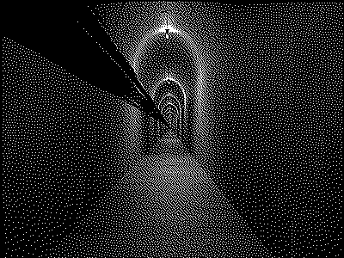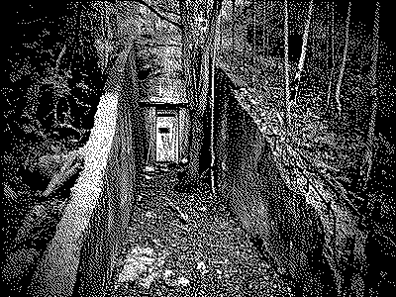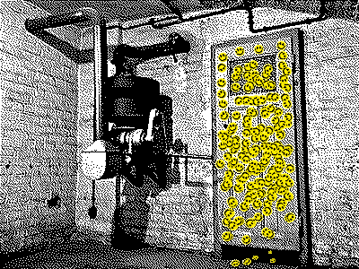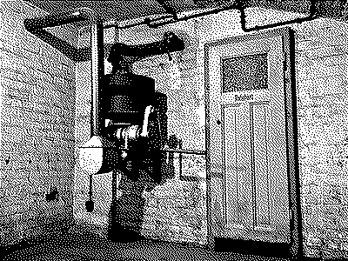

FEATURES

* Edible smiley sticker
* More than one ending
* Eldritch Horror

FUTURE

* Tastier smiley sticker
* More than two endings
* Liminal spaces
* More GRAPHICS

STYLE

* Yellow smiley sticker
* Beautiful DITHERED IMAGES
* Gray, black & yellow

A trip you will never return from.

SMILEY STICKER